# **Documentation of Week 1**

## **Lecture 1 Practice**

* + Introduction Of Course

## **Lecture 2 Practice**

* + Introduction Git
  + What is Version control system
  + How it helps us to have a track of all the files we changed over time
  + How to manage code
  + How the VCS helps while working with teams
  + Creating Repository

# **Documentation of Week 2**

## **Lecture 3 Practice**

* + I am trying to create a new git repository and will run some commands of git for learning purposes. Details of each step is given with a screen shot.

### **Step 1:** Create a repository on github website.

#### **Step 1.1:** Go to [github.com/new](https://github.com/new)

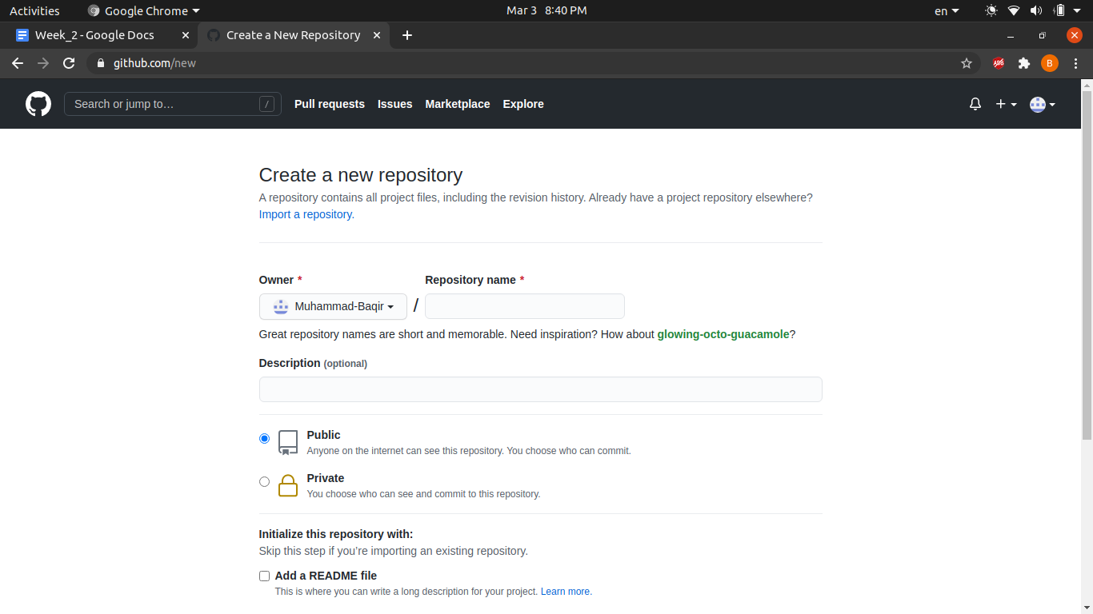

#### **Step 1.2:** Enter repository name

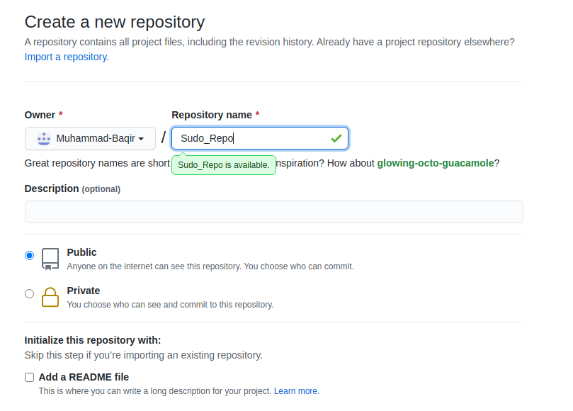

#### **Step 1.3:** Scroll down and click on the **Create Repository** button. You will be redirected to your repository home page.

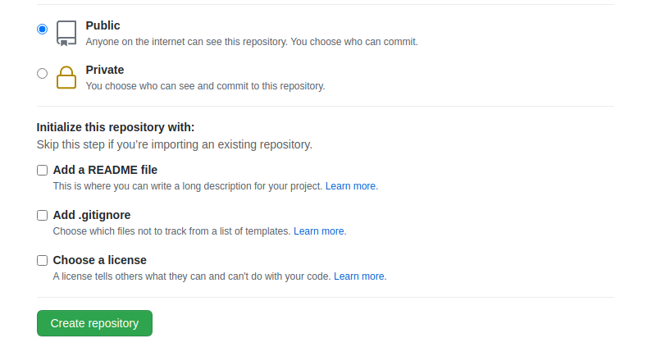

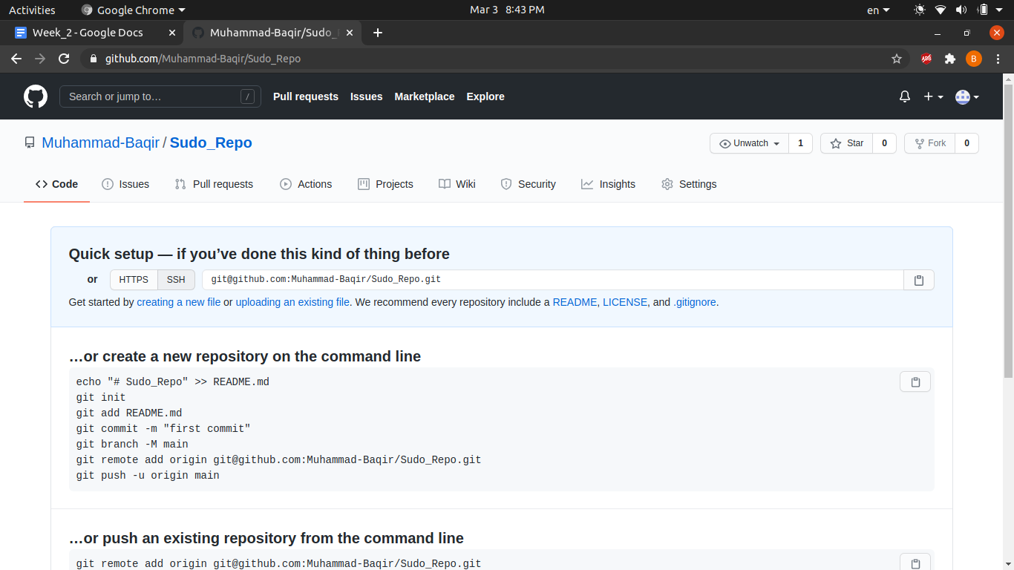

### **Step 2:** After creating a repository online. Let's try to clone it, so that it can be used on your PC.

#### **Step 2.1:** Copy the repository url. You can either copy HTTPS or SSH. I will copy SSH url.

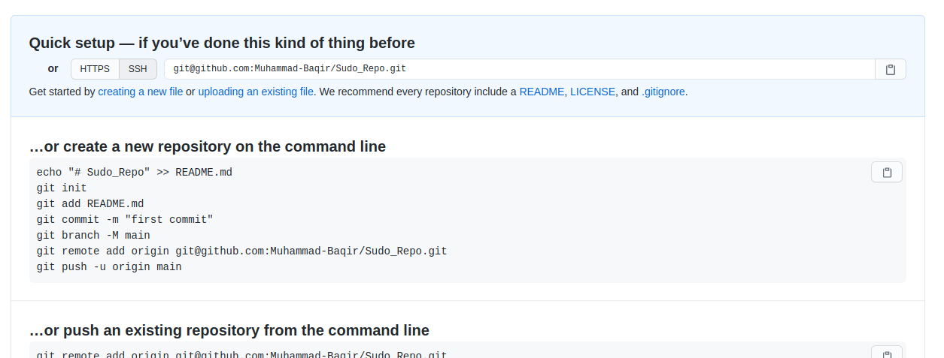

#### **Step 2.2:** Open terminal. Change the directory where you want to clone and enter **git clone repo_url** command. Git will clone the repository.

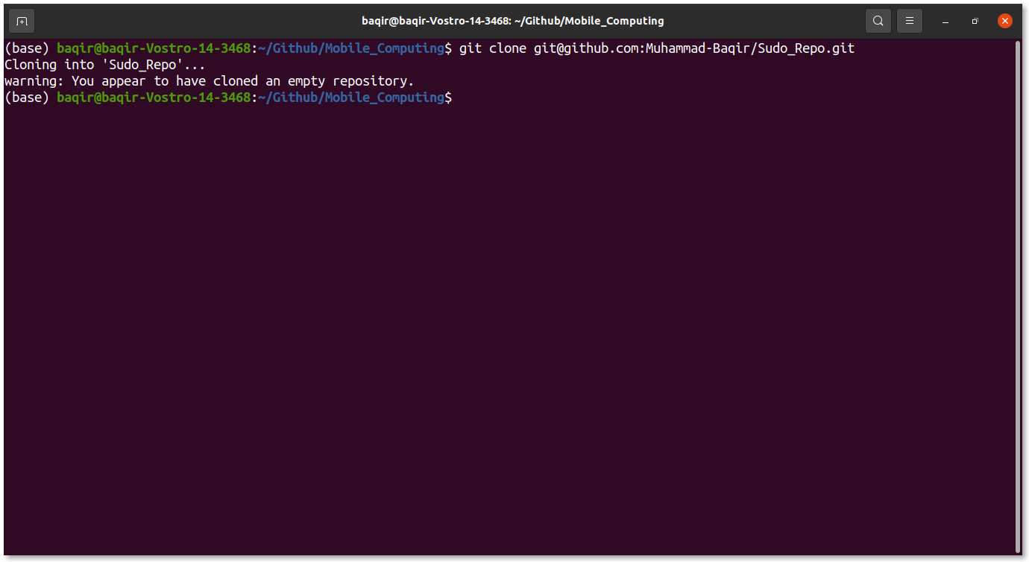

### **Step 3:** Now we have cloned the repository. Let’s add a new file and push it.

#### **Step 3.1:** Firstly get into the repo directory using **cd directory_name** command.

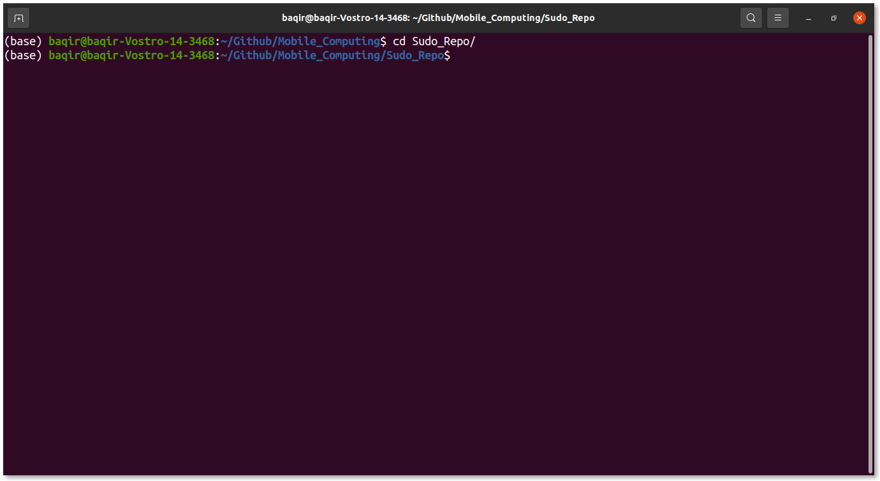

#### **Step 3.2:** Create a new file and add some random stuff.

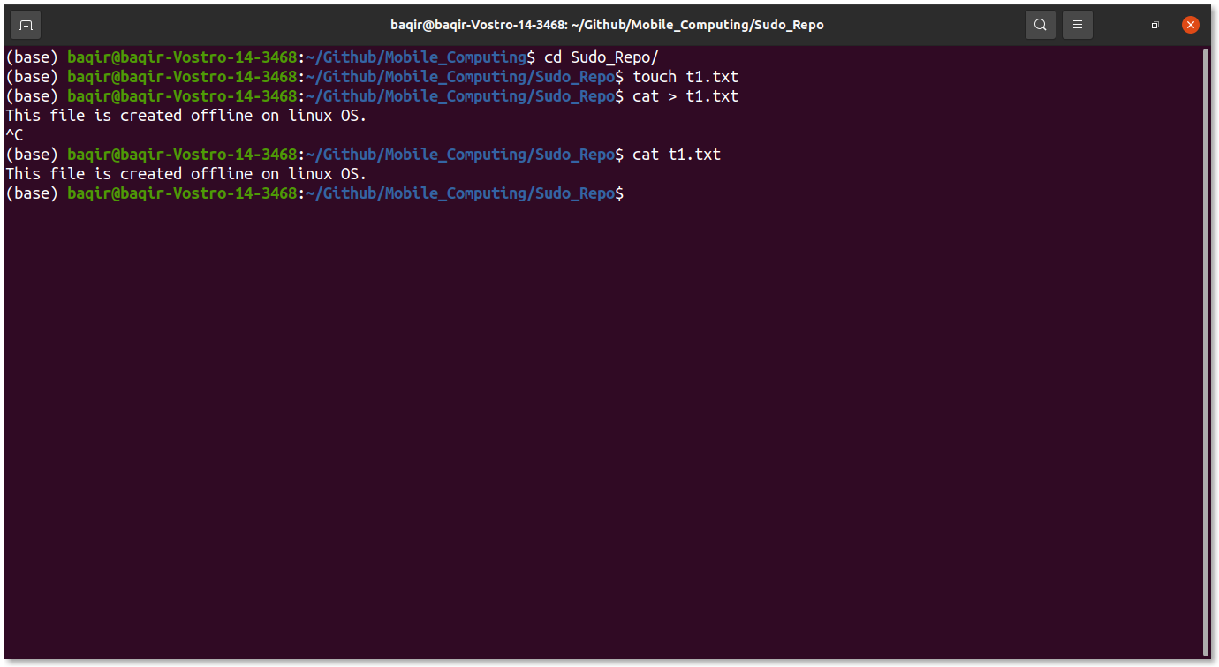

#### **Step 3.3:** Clear the screen and enter **git status** command.

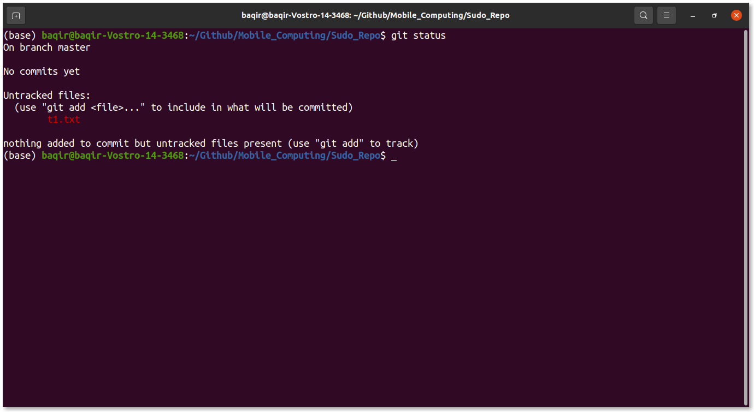

#### **Step 3.4:** Here you can see that under **Untracked files:** t1.txt is highlighted in red. Which means that this file is not yet tracked by git.

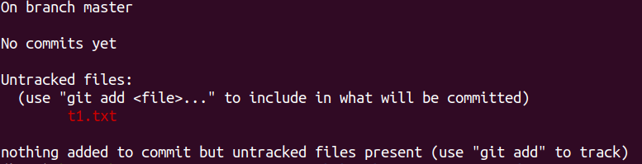

#### **Step 3.5:** So we have to inform git to track the file by entering **git add fileName** command. Enter the command and again see status. Now you can see that git is tracking the file but it is not committed.

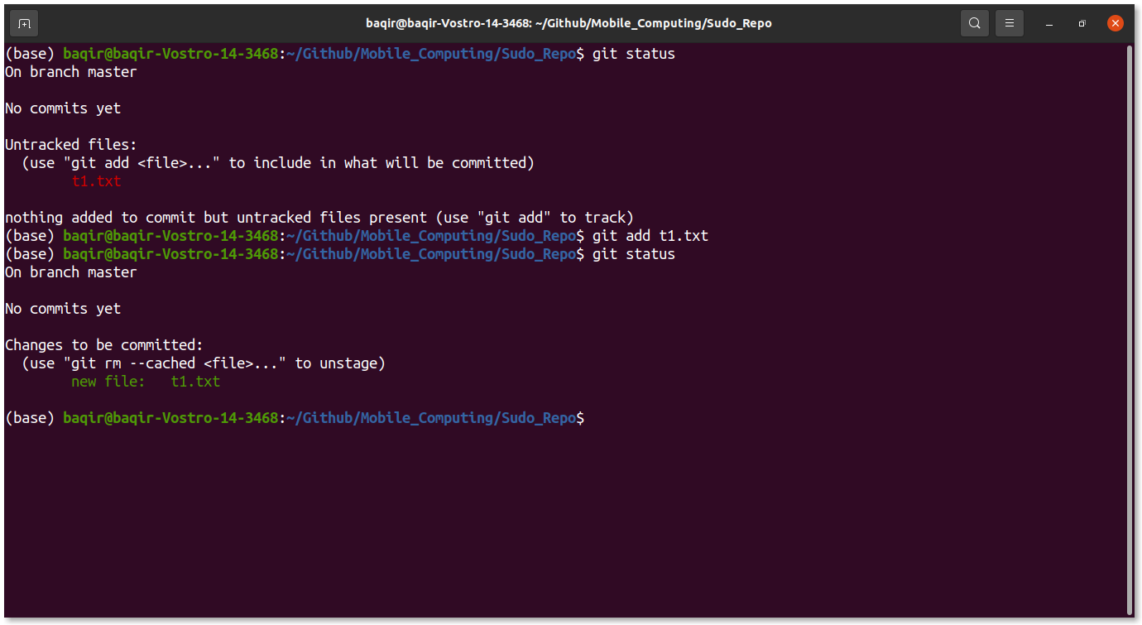

#### **Step 3.6:** So clear the screen and enter command **git commit -m “Any meaningful message”**. And again check git status. Now you can see that there is nothing to commit.

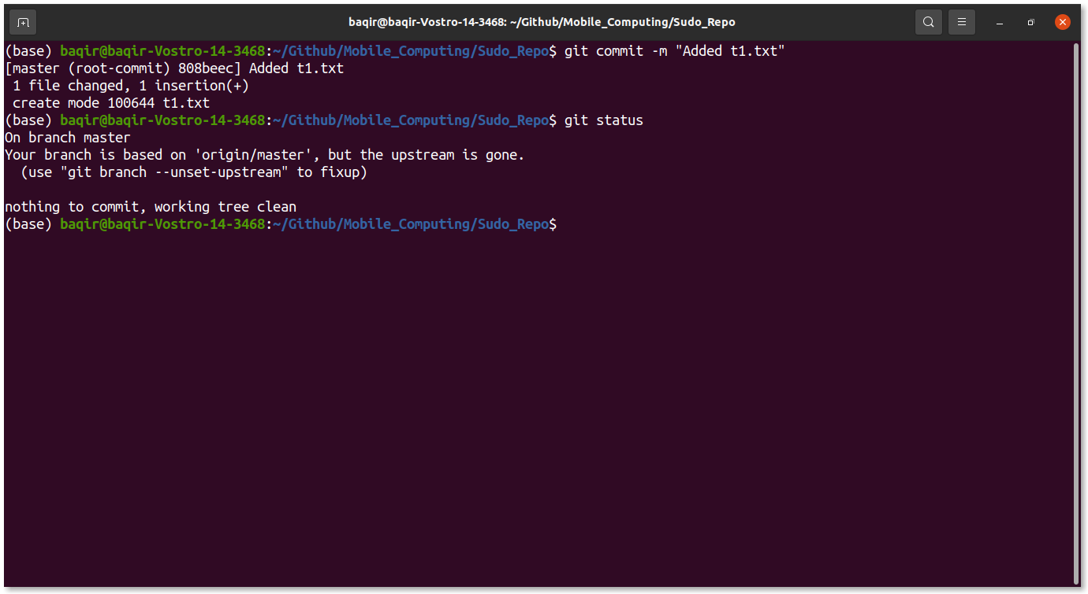

#### **Step 3.7:** Now we have committed the changes. But still these changes are not visible online. The reason is that we have to push the repo. So enter **git push** command. Now you can see changes on Github repo also.

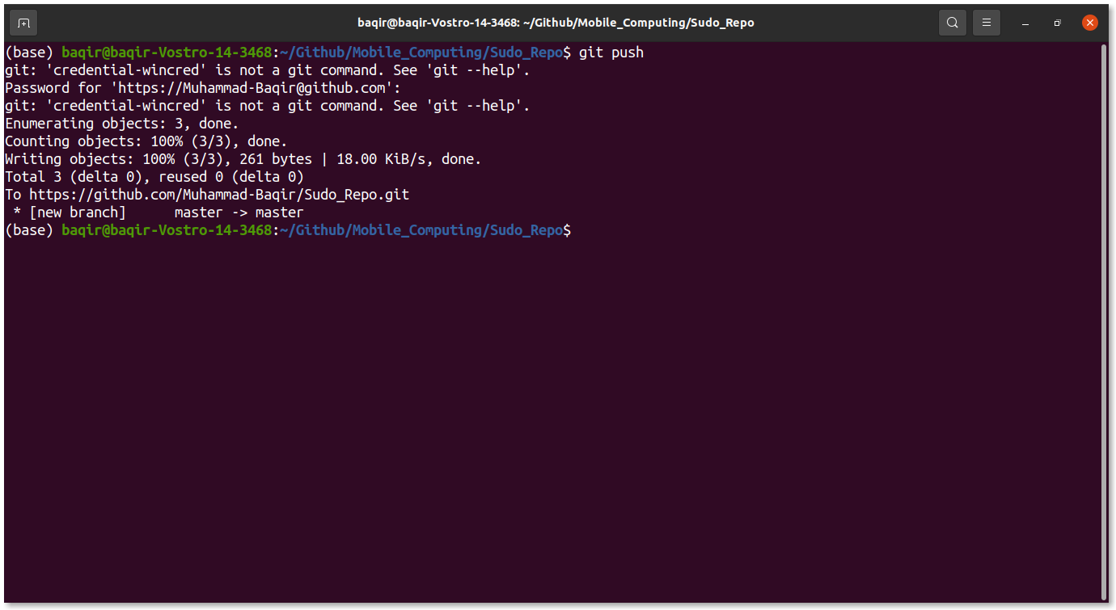

### **Step 4:** Now let’s try to add a README.md file online and pull the changes offline.

#### **Step 4.1:** Go to your Github repository homepage and click on **Add a README** button.

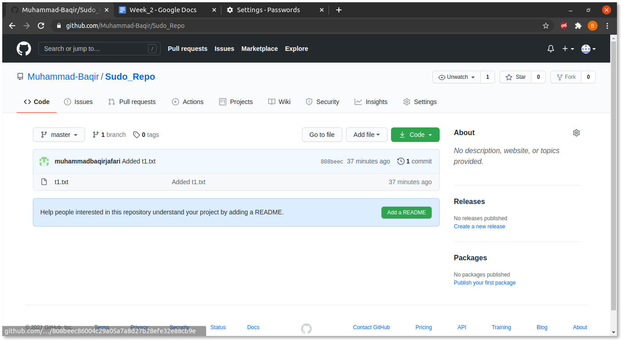

#### **Step 4.2:** You will be redirected to a new url where you can edit your newly created README file. Add some random stuff.

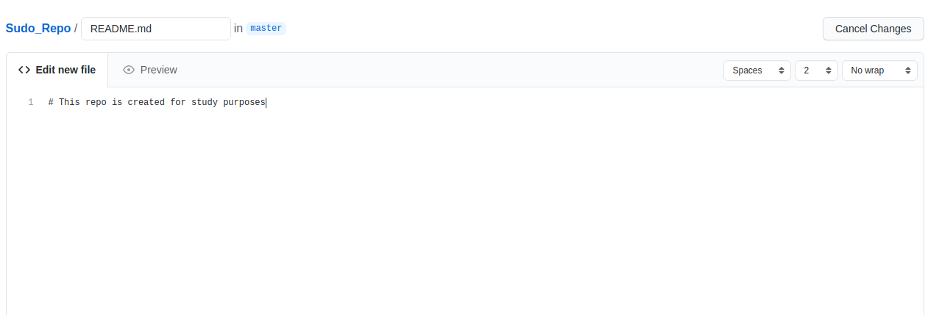

#### **Step 4.3:** Scroll down and click on **Commit new file** button. Now you will be redirected to the repo home page and a new README.md file is also added.

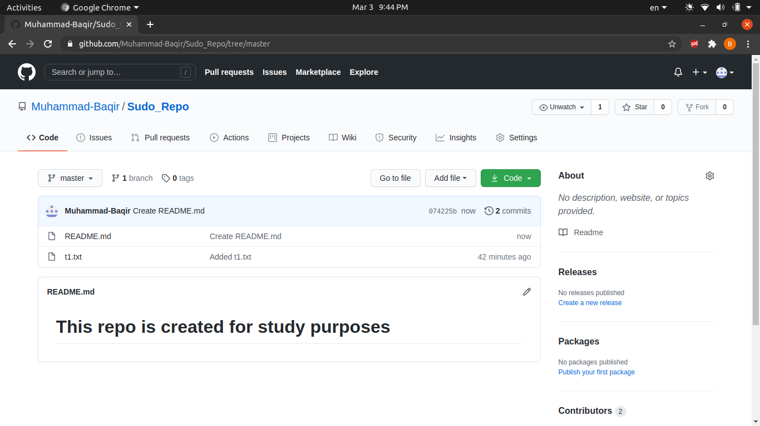

#### **Step 4.4:** To see changes offline. Go to terminal and enter **git pull** command.

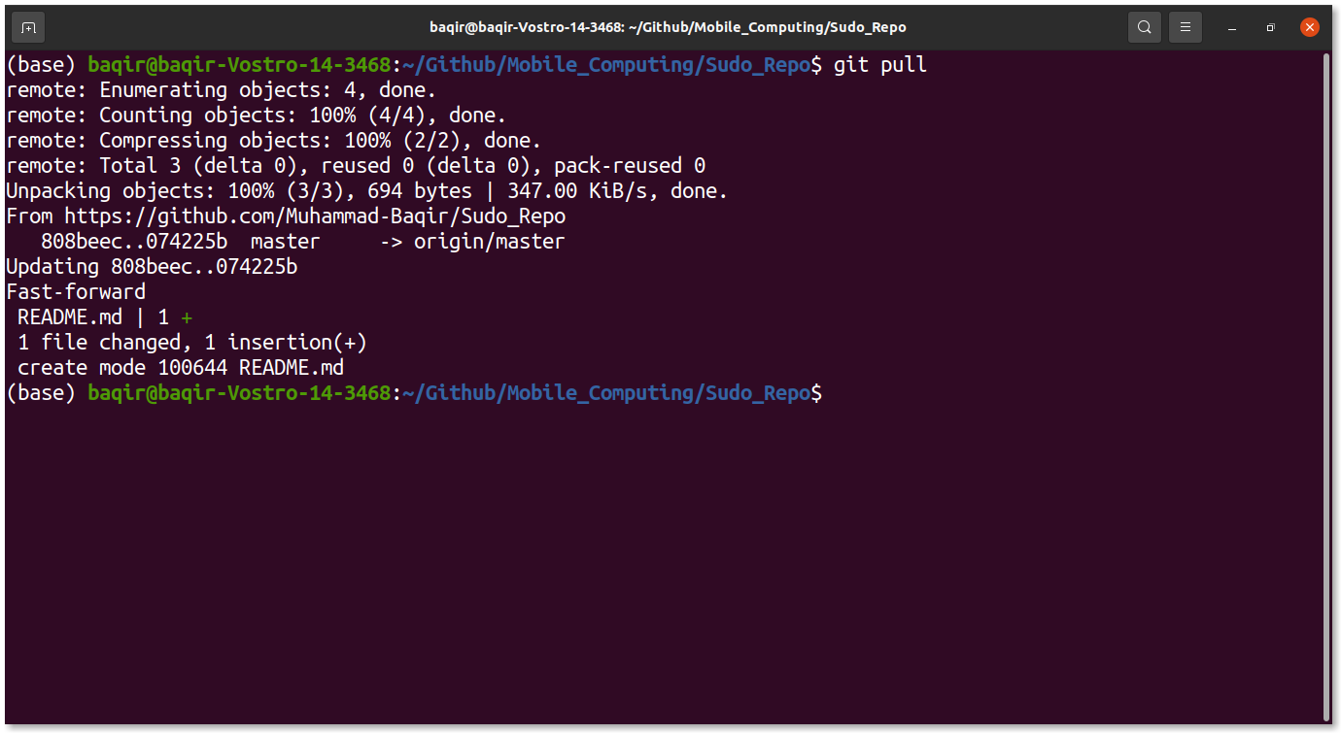

#### **Step 4.5:** Now you can see that the README file is available offline.

### **Step 5:** Now lets play with git branches.

#### **Step 5.1:** In terminal enter **git checkout -b new_branch_name**. Now enter the git **branch** and you can see the new branch is created.

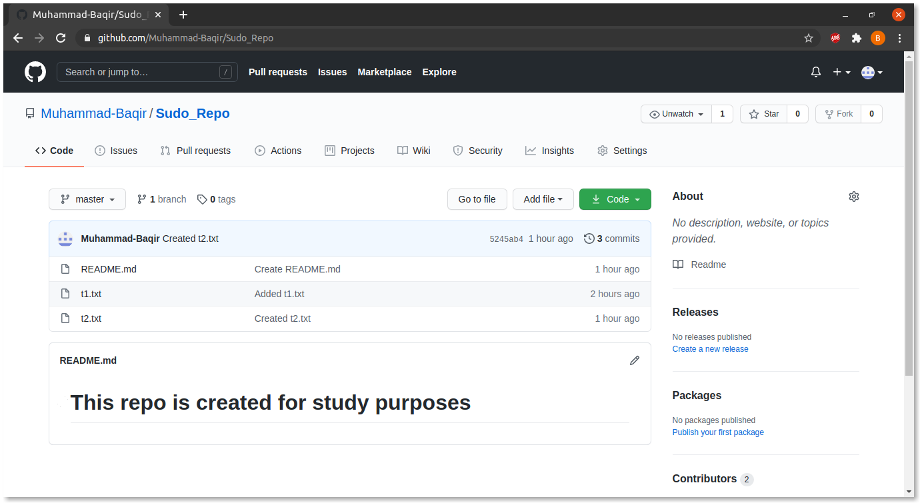

#### **Step 5.2:** Create a new file there and commit the changes.

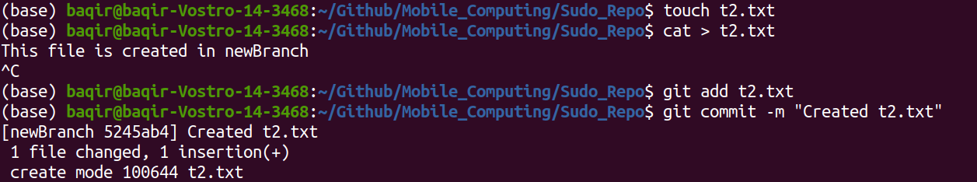

#### **Step 5.3:** Now enter **git push -u origin new_branch_name** to push the changes.

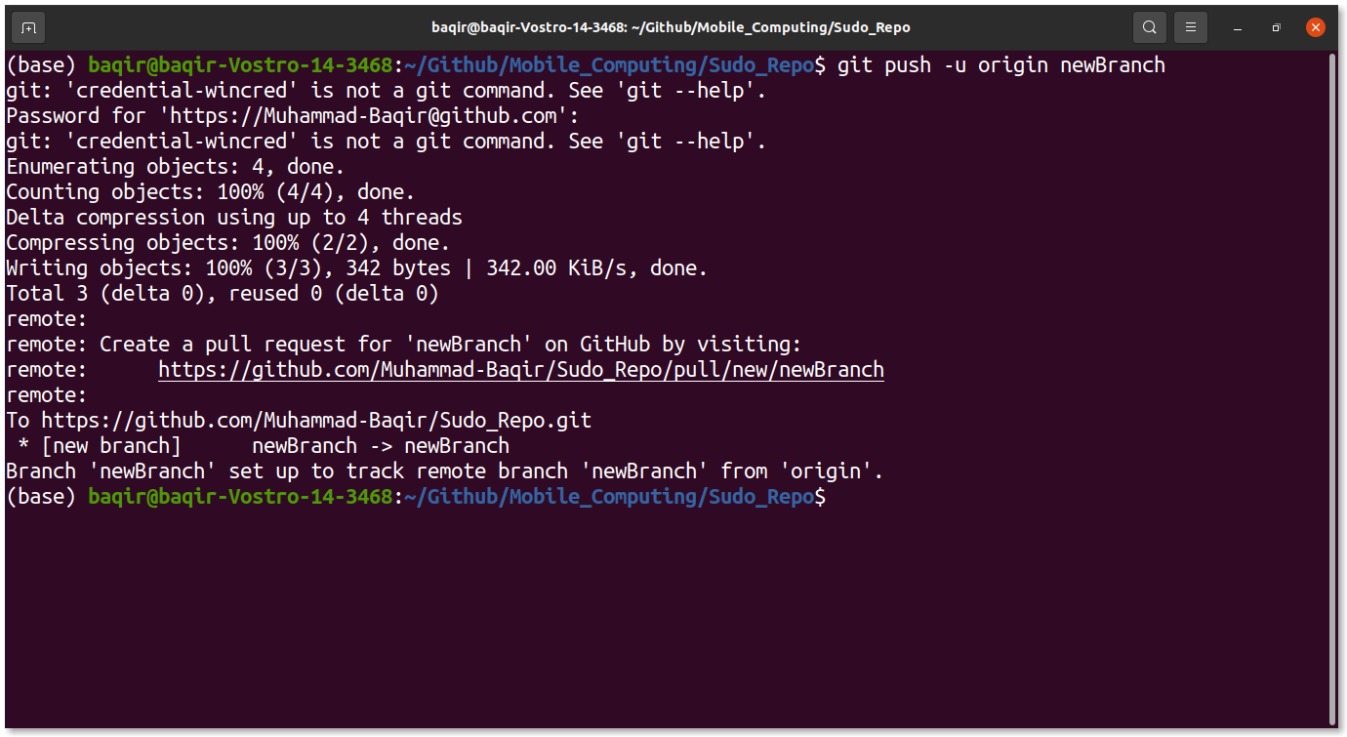

#### Step 5.4: Now you can see that there are two branches available. Now let’s try to merge newly created branch to master branch.

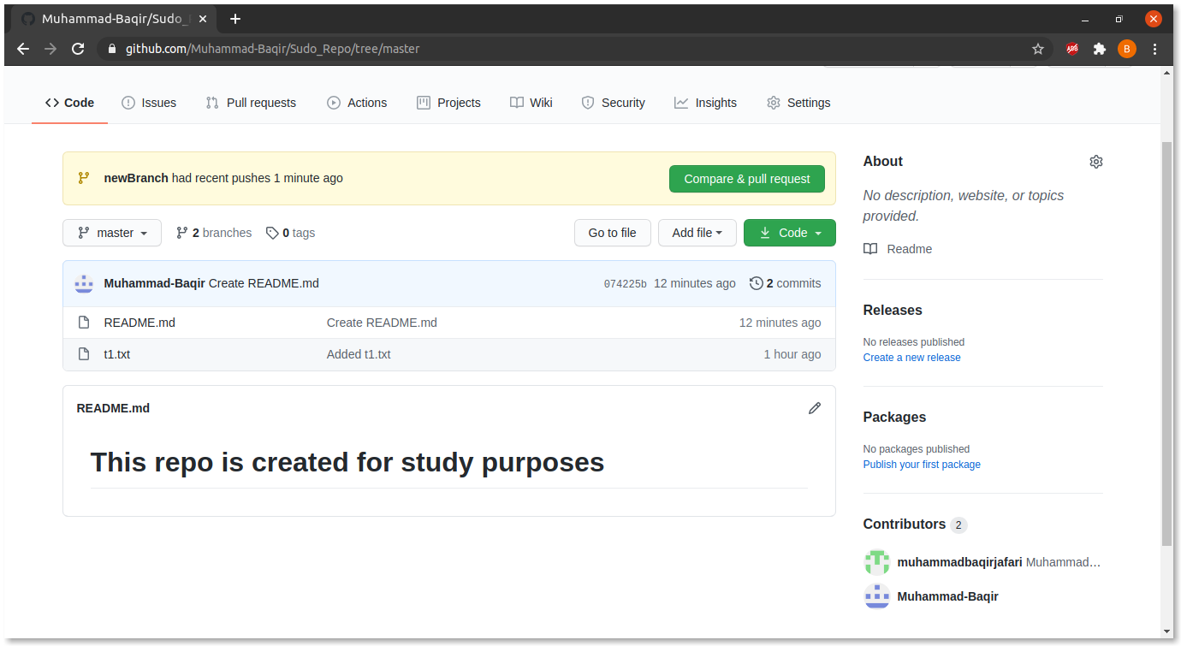

#### **Step 5.5:** In terminal enter command **git checkout master**, in order to switch to master and branch and then enter **git merge origin new_branch_name**.

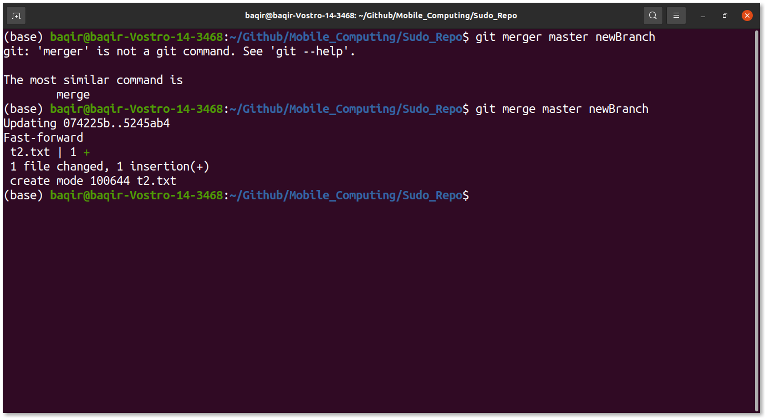

#### **Step 5.6:** Now push the changes so you can see the changes online

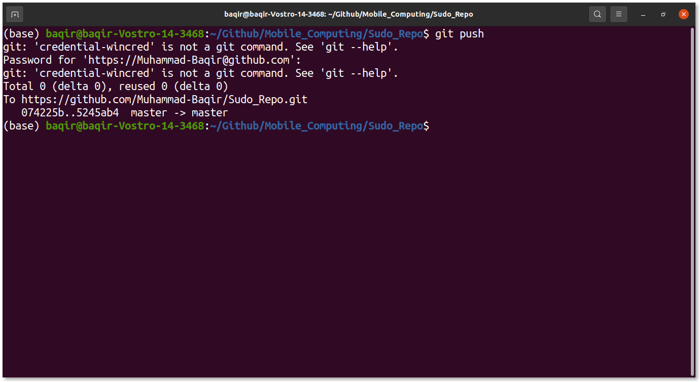

#### **Step 5.7:** You can see that the master branch also has a t2.txt file.

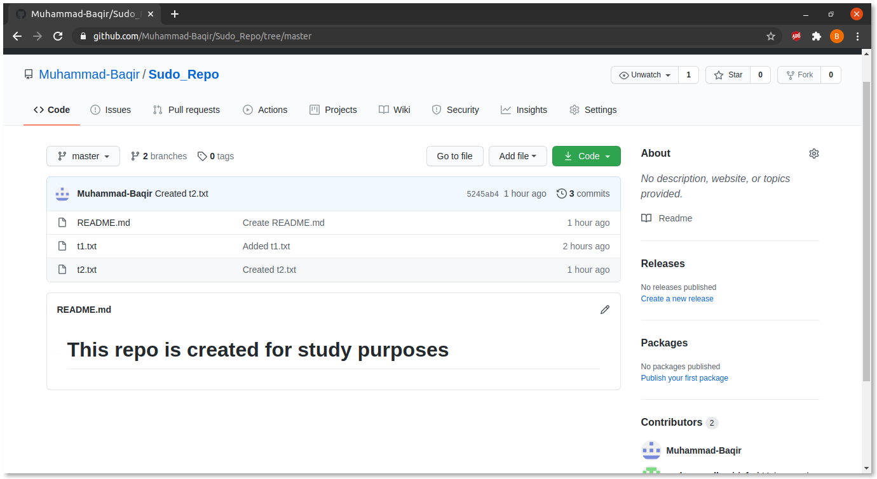

#### **Step 5.8:** You can also delete older branch by clicking on branches icon. And you will be redirected to a new page.

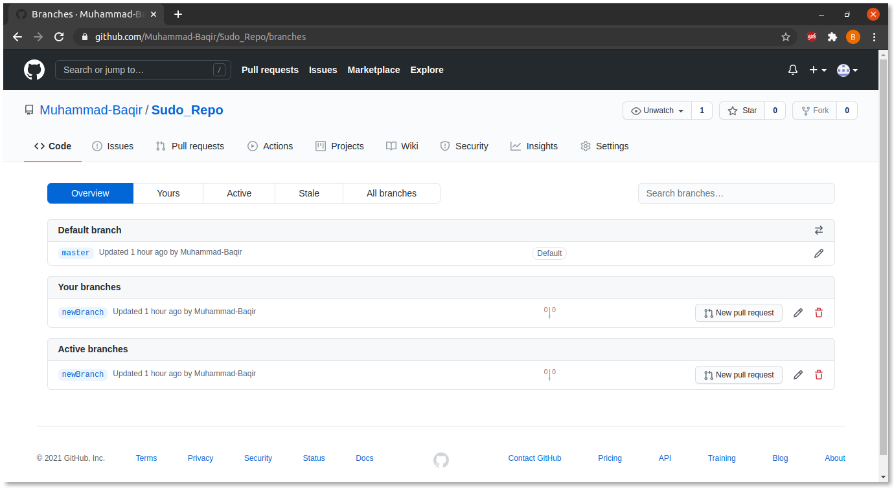

#### **Step 5.9:** Here you can click on delete button and your branch will be deleted.

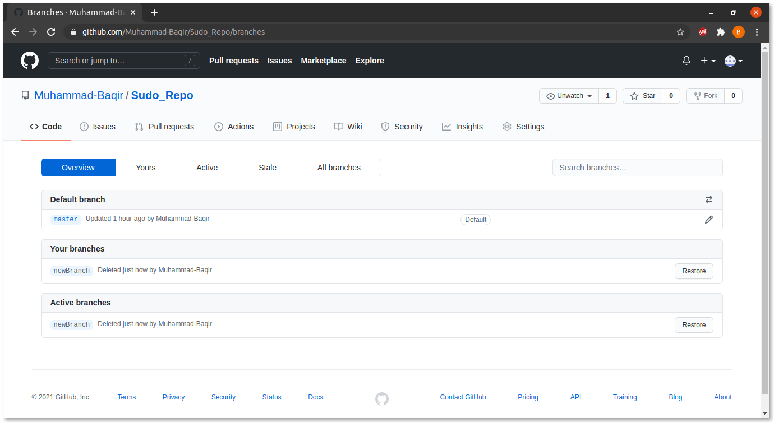

#### **Step 5.10:** Now go to the home page and you can see only master branch is available.



## Lecture 4 Practice

* + Now, let’s play with Android Studio.

### Step 1: Open Android Studio.

#### Step 1.1: Open the bin folder of android studio and run the following command **sudo ./studio.sh**

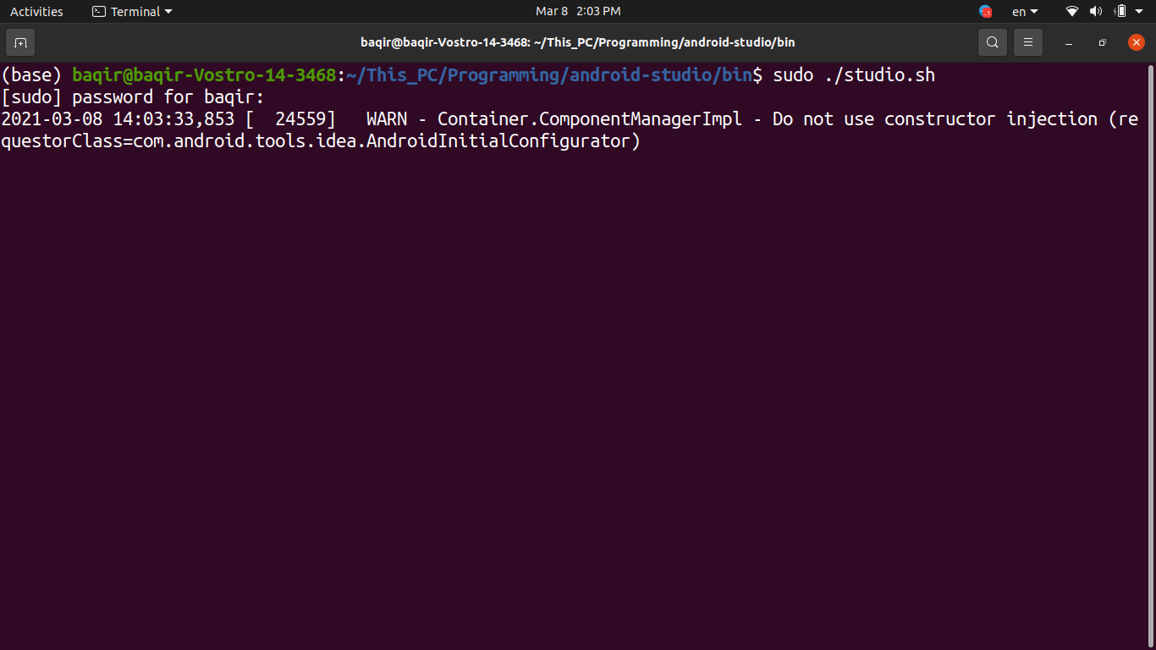

#### Step 1.2: From the menu opened click on **Create New Project**

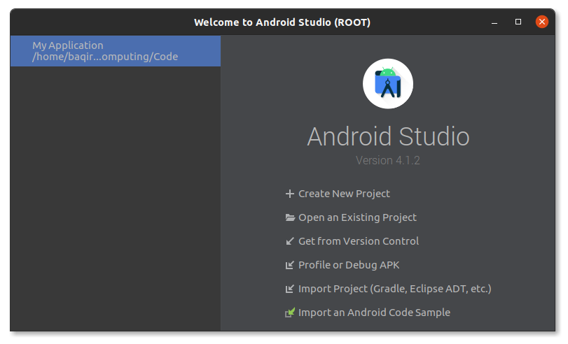

#### Step 1.3: Now select **Empty Activity** template and select **next**.

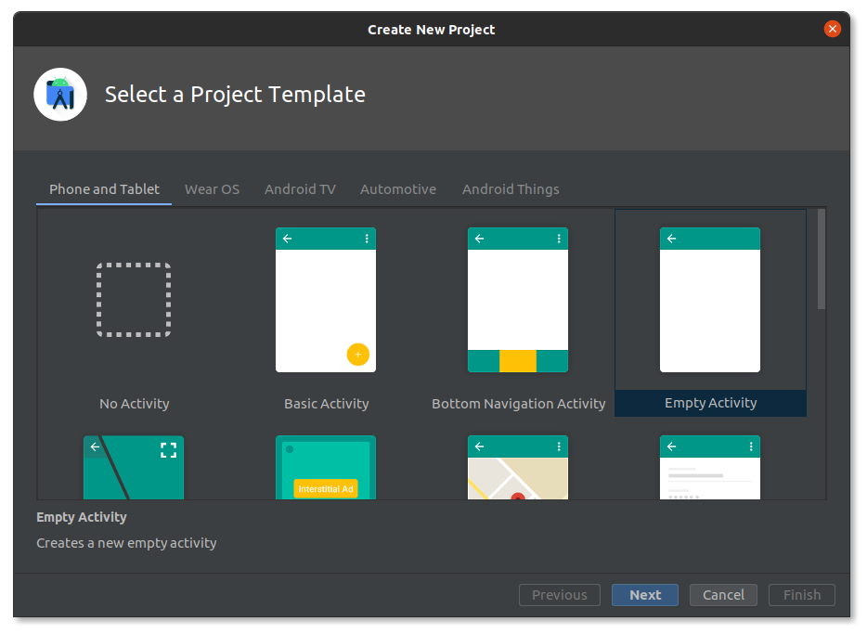

#### Step 1.4: Enter the name of the application and set its location. And click on **Finish.**

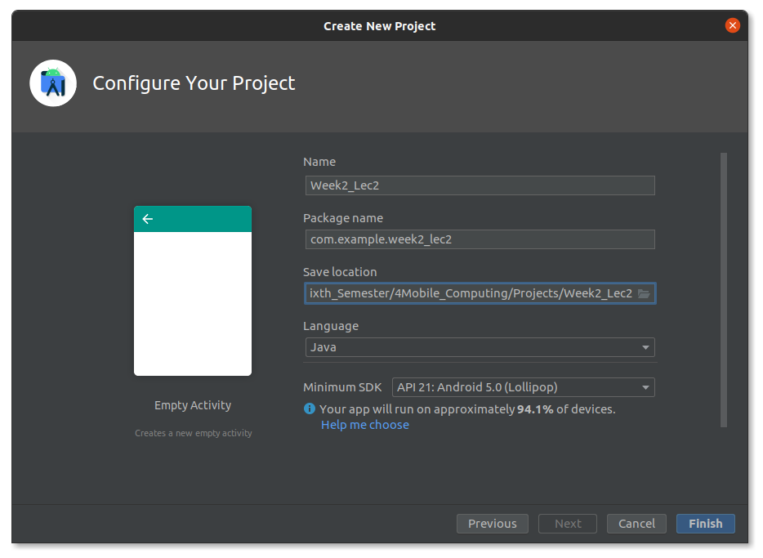

#### Step 1.5: Now wait a moment and Android Studio is ready for coding.

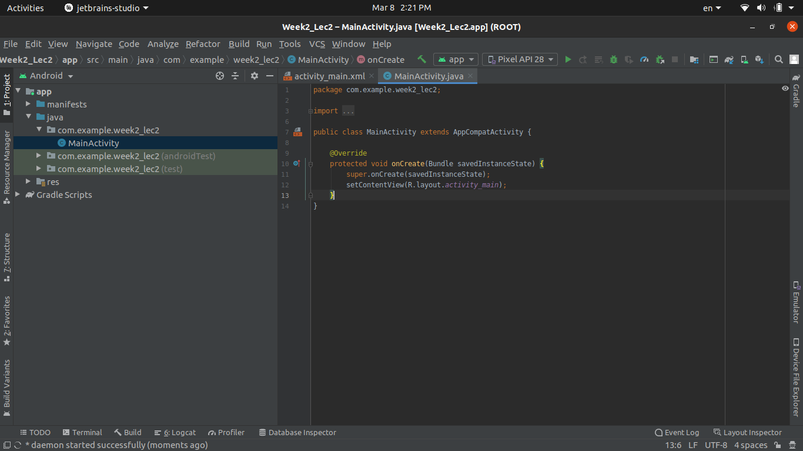

### Step 2: Run a simple Hello World App.

#### Step 2.1: Enter **Shift + F10** or click on green arrow button to build and run the app.

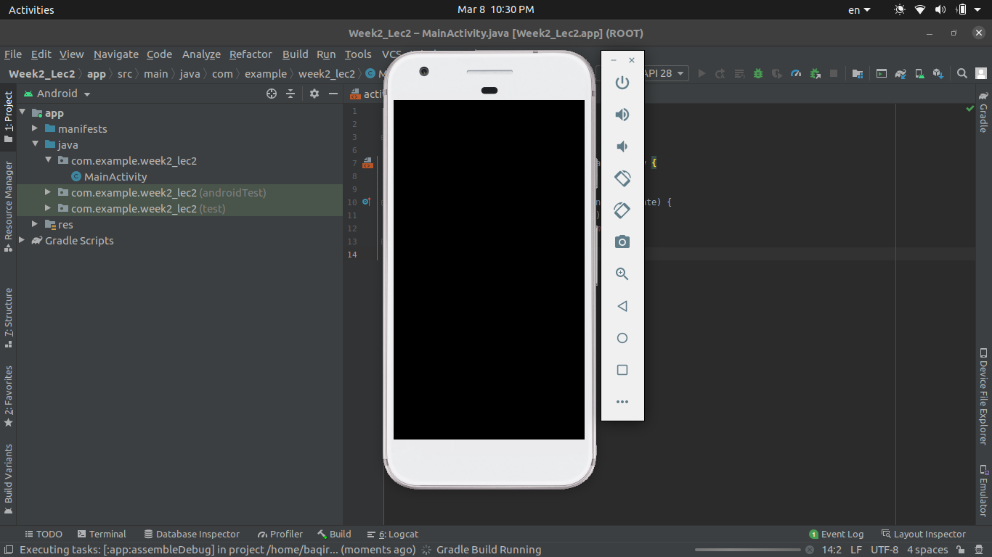

#### Step 2.2: Wait some time and you will see the Hello World app run on virtual android device.

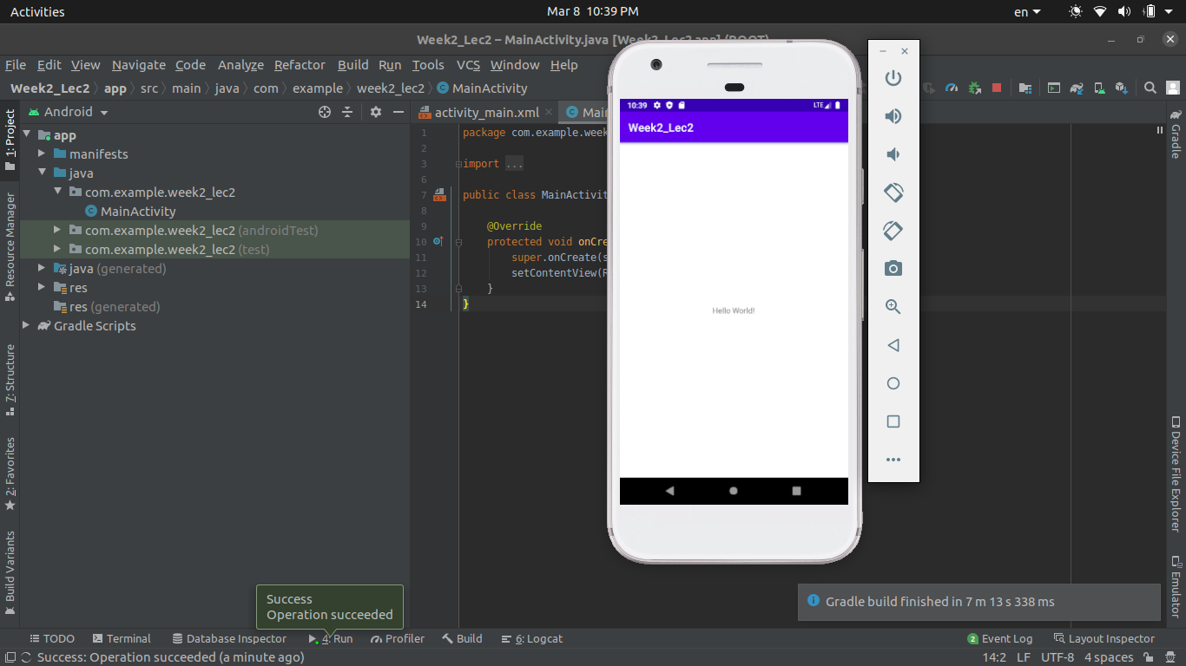

### Step 3: Add some buttons.

#### Step 3.1: Stop the app. Open **activity_main.xml.**

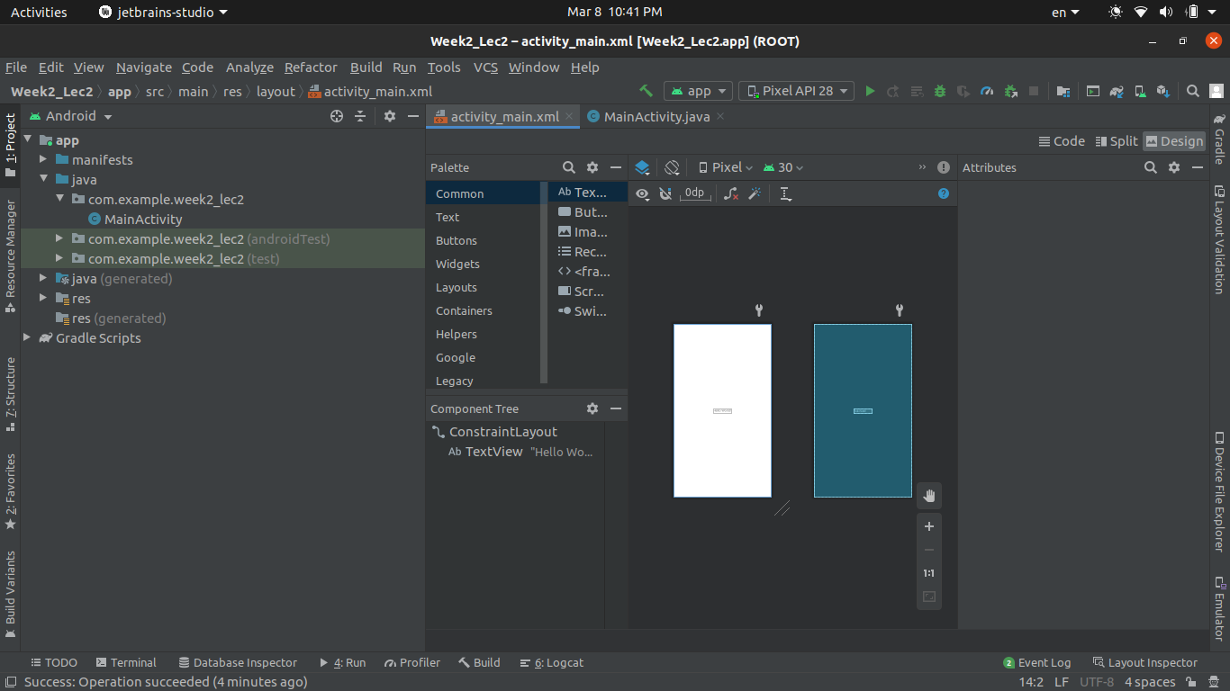

#### Step 3.2: Under the **Palette** menu choose Buttons tab. And now drag and drop simple button from the menu next to it.

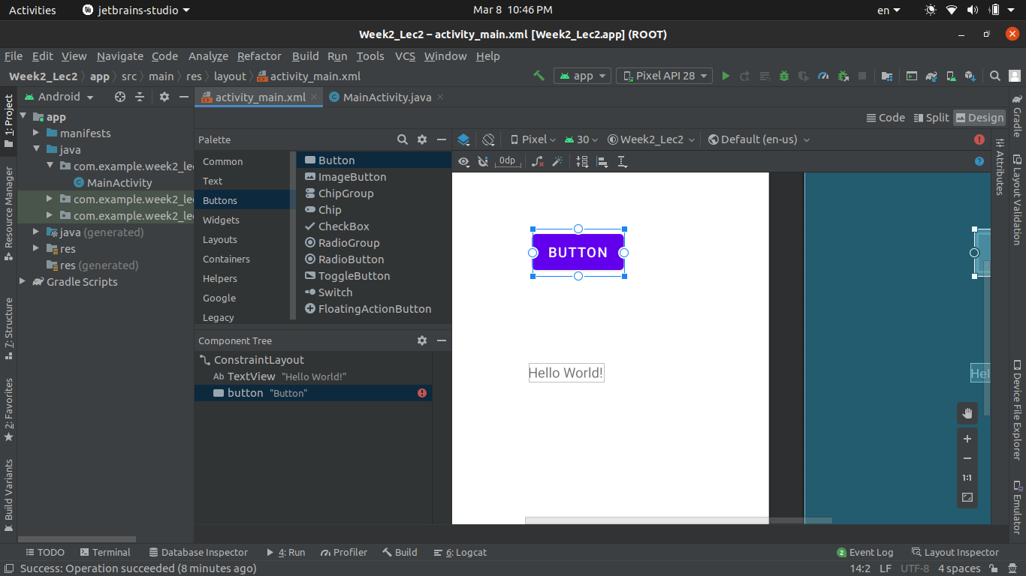

#### Step 3.3: Adjust the location of the button.

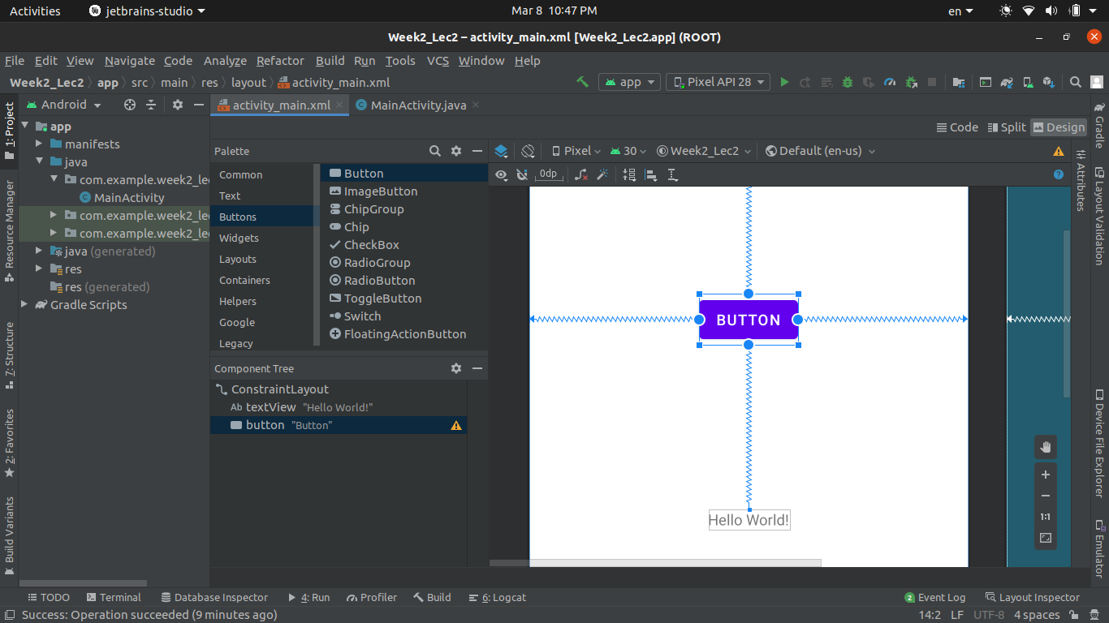

#### Step 3.4: Again run the code and you will see the output.

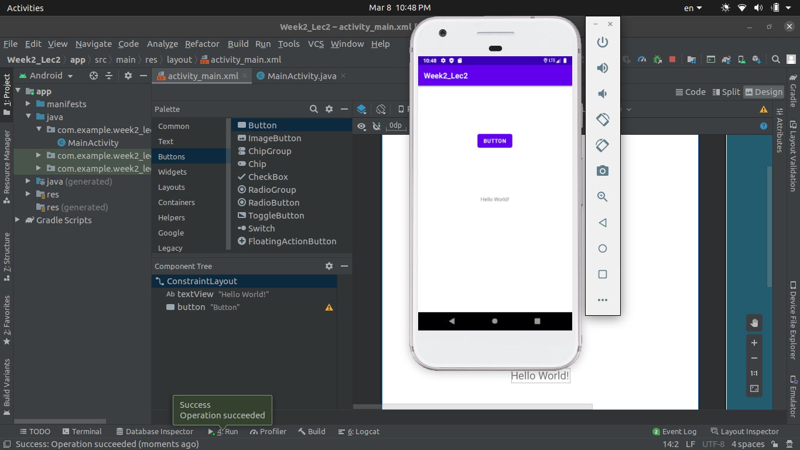

### Step 4: Add some Widgets.

#### Step 4.1: Stop the app. From **Palette** select Widgets. And drag and drop calendar widget.

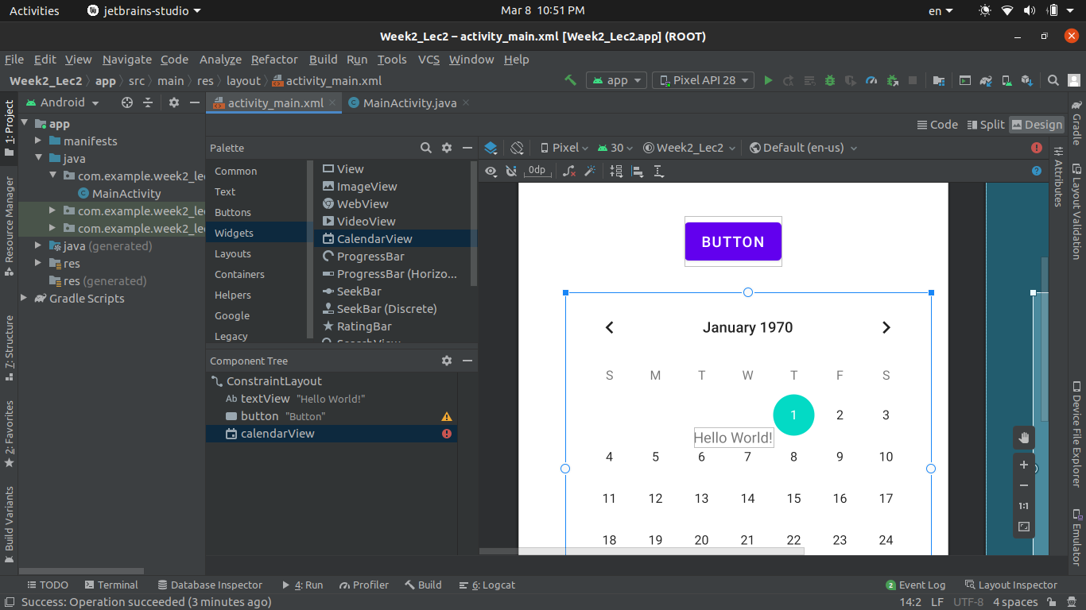

#### Step 4.2: Adjust calendar and run the app.

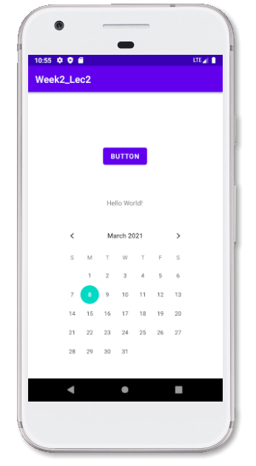

### Step 5: Add some more Widgets.

#### Step 5.1: From widgets drag and drop search widget.

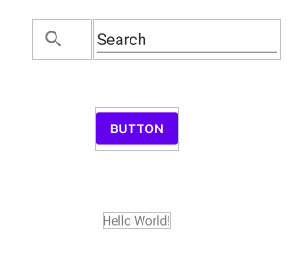

#### Step 5.2: Build and Run the app and see the output.

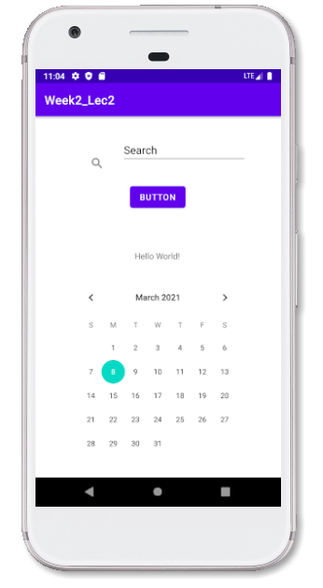

# **Documentation of Week 3**

## **Lecture 5 Practice**

* + We learnt about what is View and View Group
  + Linear Layout
  + Constraint Layout

**View Group _ Linear Layout**

I used linear layout as main/root element and two text views as Views inside that view group.

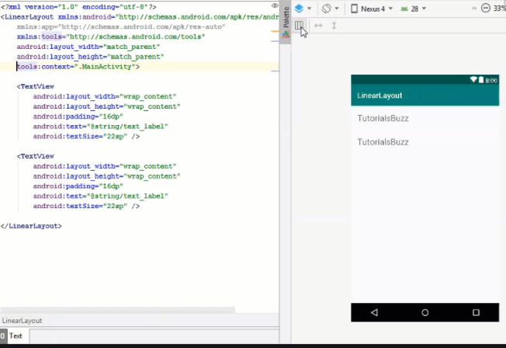

**Constraint Layout**

I used linear layout as main/root view group with some other views

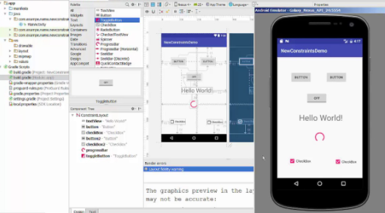

## **Lecture 6 Practice**

**Activities and Intents**

* What is an activity
* Activity Functions
* Manifest File
* What is Intent

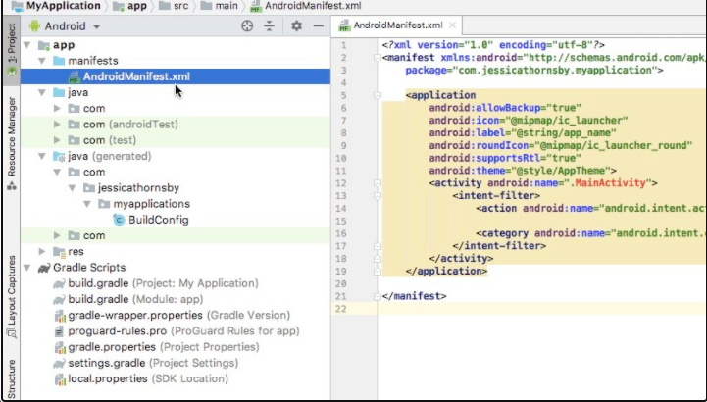

* Implicit and Explicit Intent

Intents to Dial a number and view a link programmatically

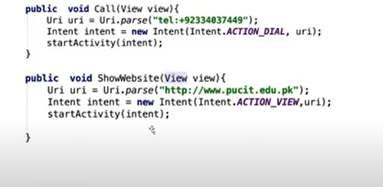

# **Documentation of Week 4**

## **Lecture 7 Practice**

NO Lecture Today

## **Lecture 8 Practice**

* + Activity Life Cycle

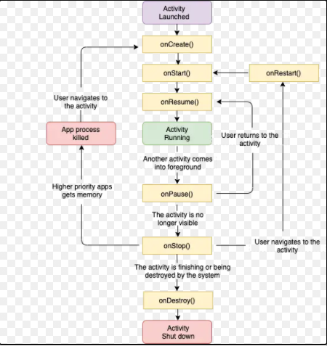

Here is implementation Results of Activity Life Cycle

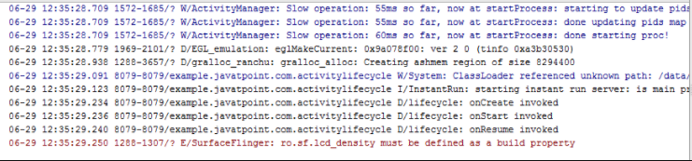

# **Documentation of Week 5**

## **Lecture 9 Practice**

* List View

List View is used to show data in form of lists. We use Adapters to make the data compatible to list view so data could be displayed

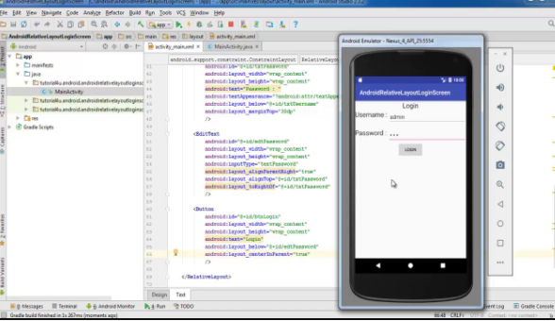

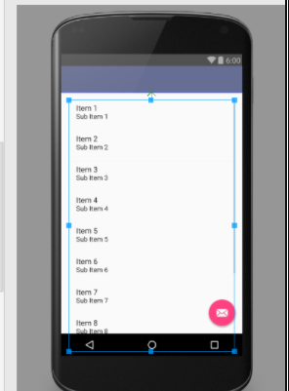

## **Lecture** (Makeup Lecture)

**Android animations**

**Implementation of Seek bars**

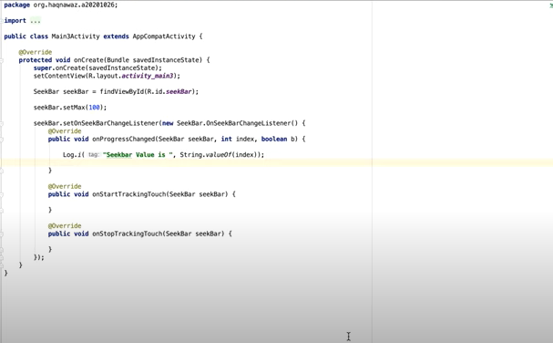

**Implementation of Seek bar values to a list view as a table**

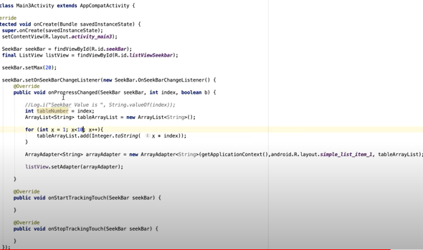

**Adding Videos and Audios**

For adding controls, we use Media Control objects.

Here is implementation of how to add videos

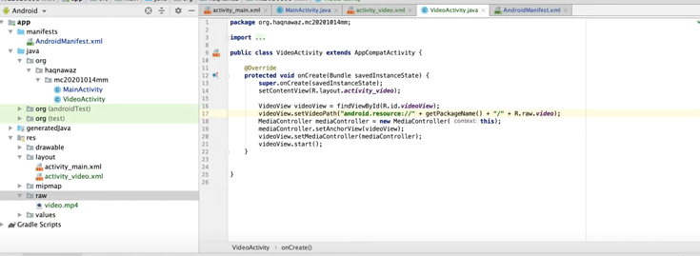

**Here is implementation of how to add Audios**

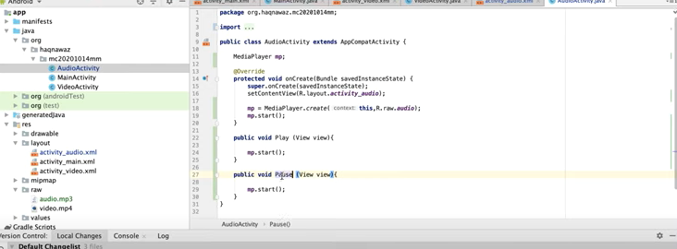

## **Lecture 10 Practice**

**Sql Lite In Android**

**Designing to explain DB operations**

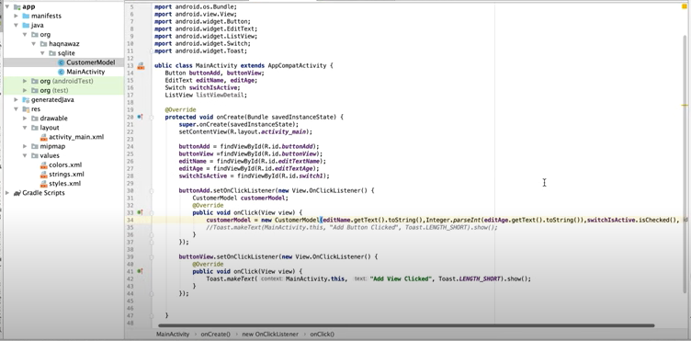

**Customer Model Class**

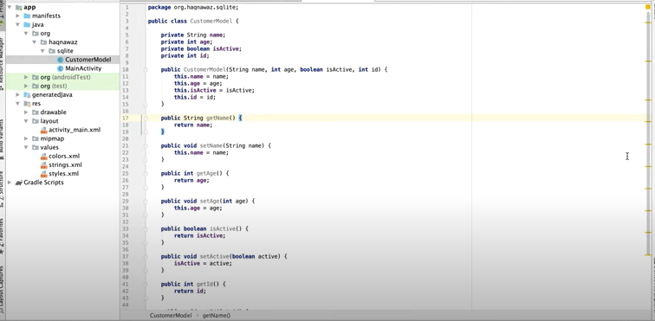

**Correct recitation of the verses**

Correct recitation of the verses of the Noble Qur’an is important for every Muslim. It becomes more difficult to learn and verify the correctness of recitation in countries where Muslims are a minority or Arabic is not their mother tongue, as well as in countries where there are not many teachers who are proficient in reciting the Qur’an. The automatic recitation corrector project bridges this gap to a large extent by providing multiple ways to learn and correct the recitation of the Holy Qur’an verses automatically via artificial intelligence. The project can be provided as a website, application on smartphones, and computers. The application works 100% automatically without human intervention.

**Evaluate it write down your comments in a document**

That’s one of the best apps and really helpful for those people wo is unable to know either they are reciting correctly or not. It also saves time and save people on relaying other people.

**Can you implement anything from it in your current project?**

Currently we are working with **Employee Management system that** an entirely different thing. So at least from this project we cannot add any feature to our project.

**How much of the task you can do in this application?**

I wish I could know about these projects before we select our Term project. In that project Deep learning concepts are being used to understand and recognize the voice of people and if they are reciting in wrong way that app will make them correct.

As per learnings in that course me and my team could implement the same UI. But instead of using Deep learnings we could use recitation API’s so first user will listen it and then try to do the same. That will help them to improve their recitations.